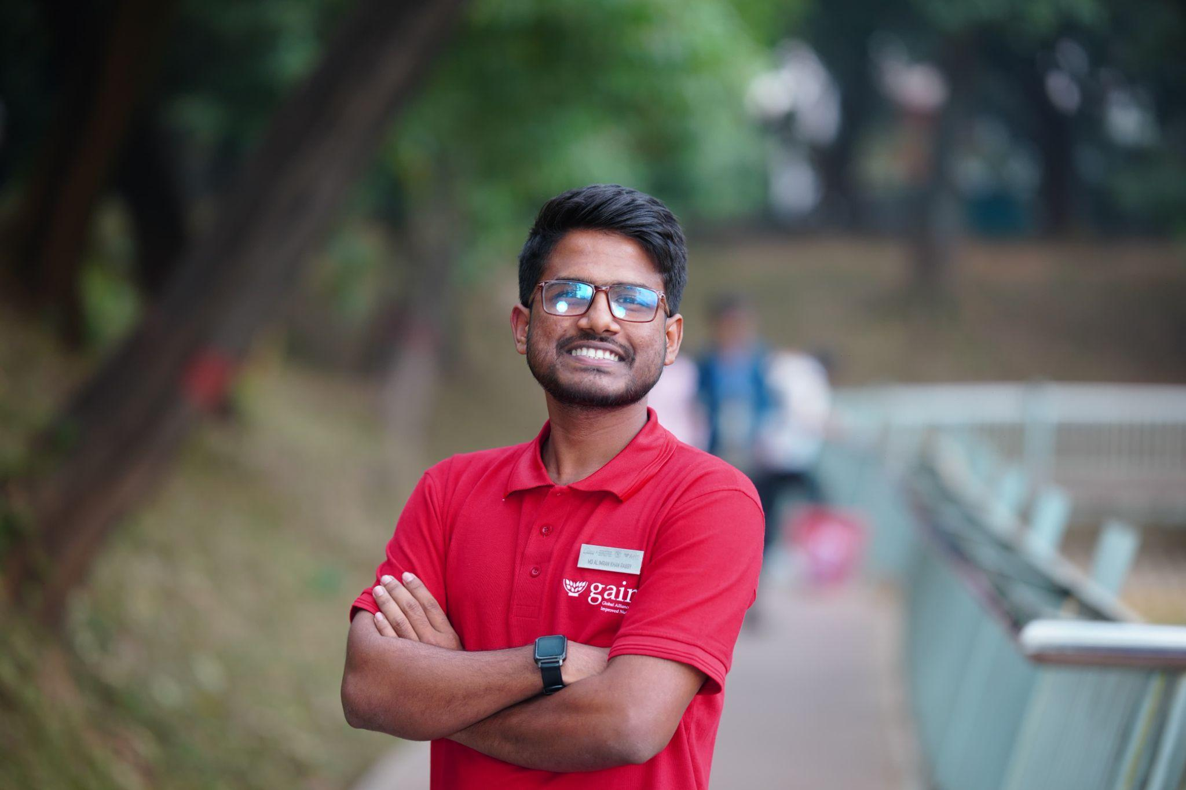
From Courtyard to Community Change: A Youth-led Nutrition Movement in Rural Bangladesh

In Tala, Satkhira, families often navigate the challenges of saline soil and limited access to affordable nutritious food. These difficulties are especially felt by women and mothers who work daily to provide balanced meals in an environment where fresh produce is scarce.
For Imran Rabby, understanding these challenges more deeply began after he joined the Food Systems Youth Leadership Training hosted by GAIN and SUN Youth Network Bangladesh. The training helped him explore how local food systems shape people’s options and how youth can support community level solutions.
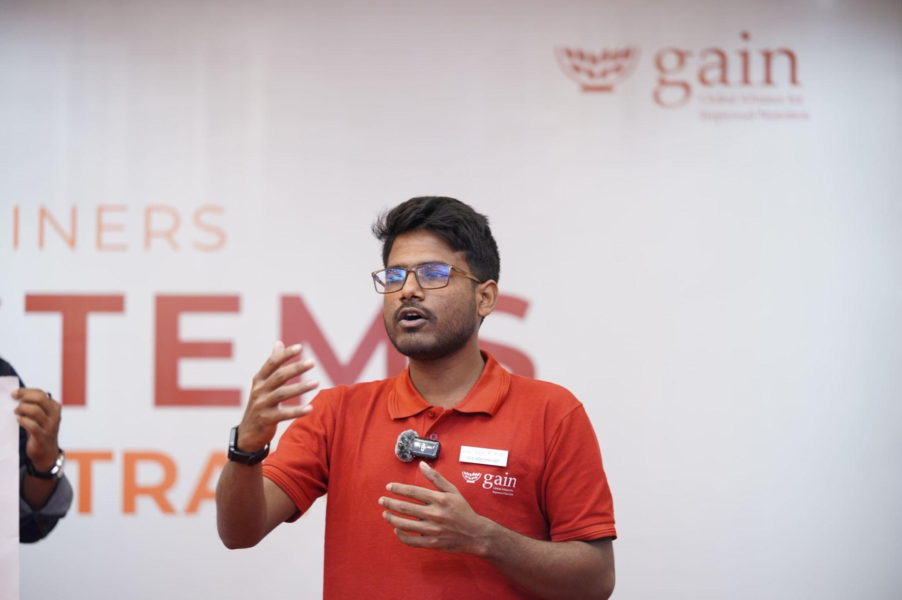
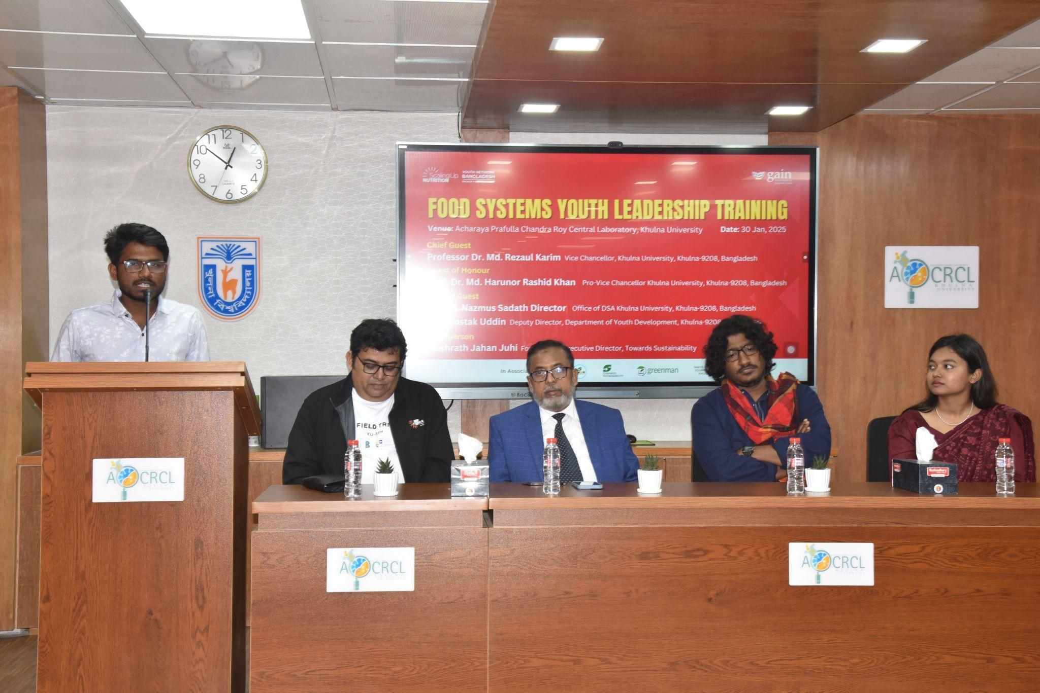
“As a youth from the coastal belt, we often dream big but struggle to turn our ideas into action. This training gave me the tools to take practical steps that respond to our community’s real needs. It was an empowering experience,” he said.

Motivated by what he learned, Imran first shared his knowledge with other young people. He organized similar training sessions at Khulna University and Patuakhali Science and Technology University, engaging thirty participants at each institution. These youth later initiated their own small projects, showing how learning can spread through peer networks.
Back in Satkhira, Imran focused on a challenge affecting many women in his community. Mothers often struggled to access nutritious food due to poor soil conditions and financial barriers. Conversations with them made the issue more personal and immediate.
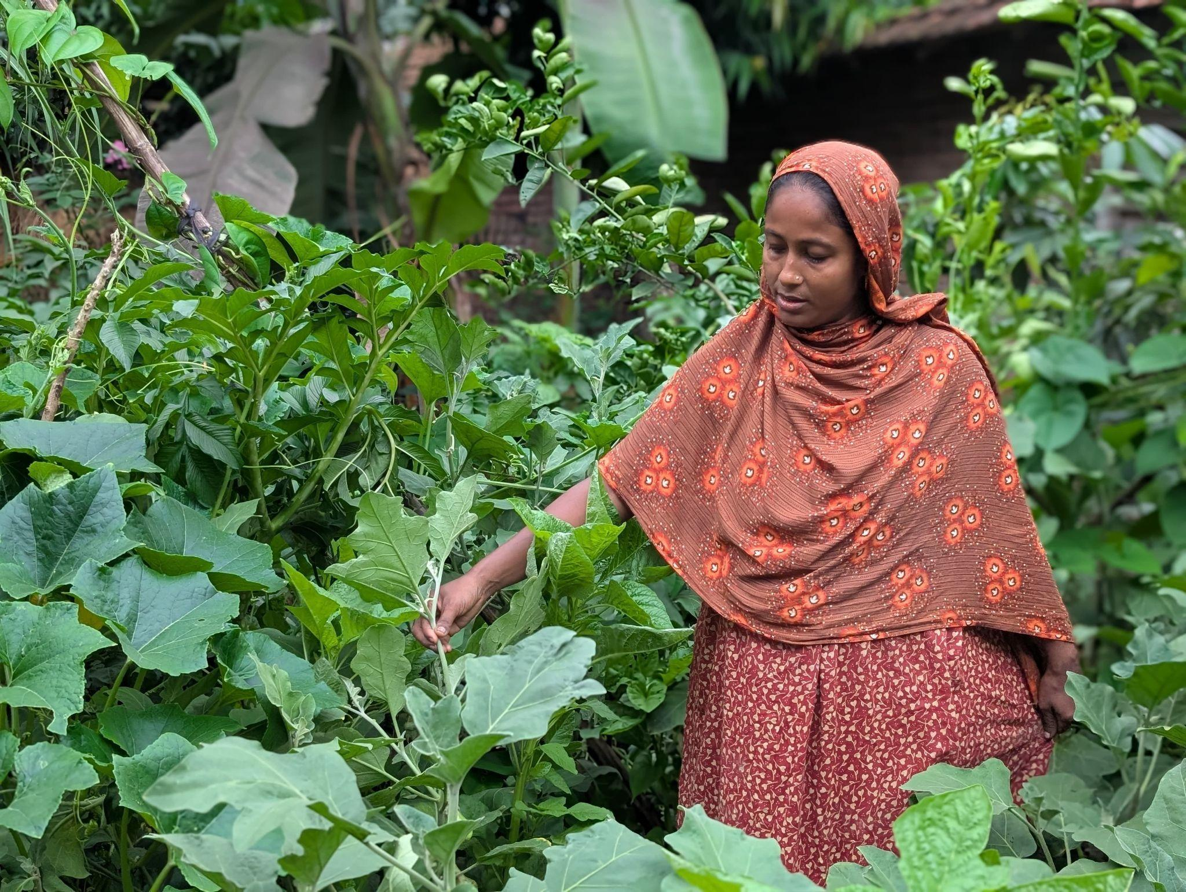
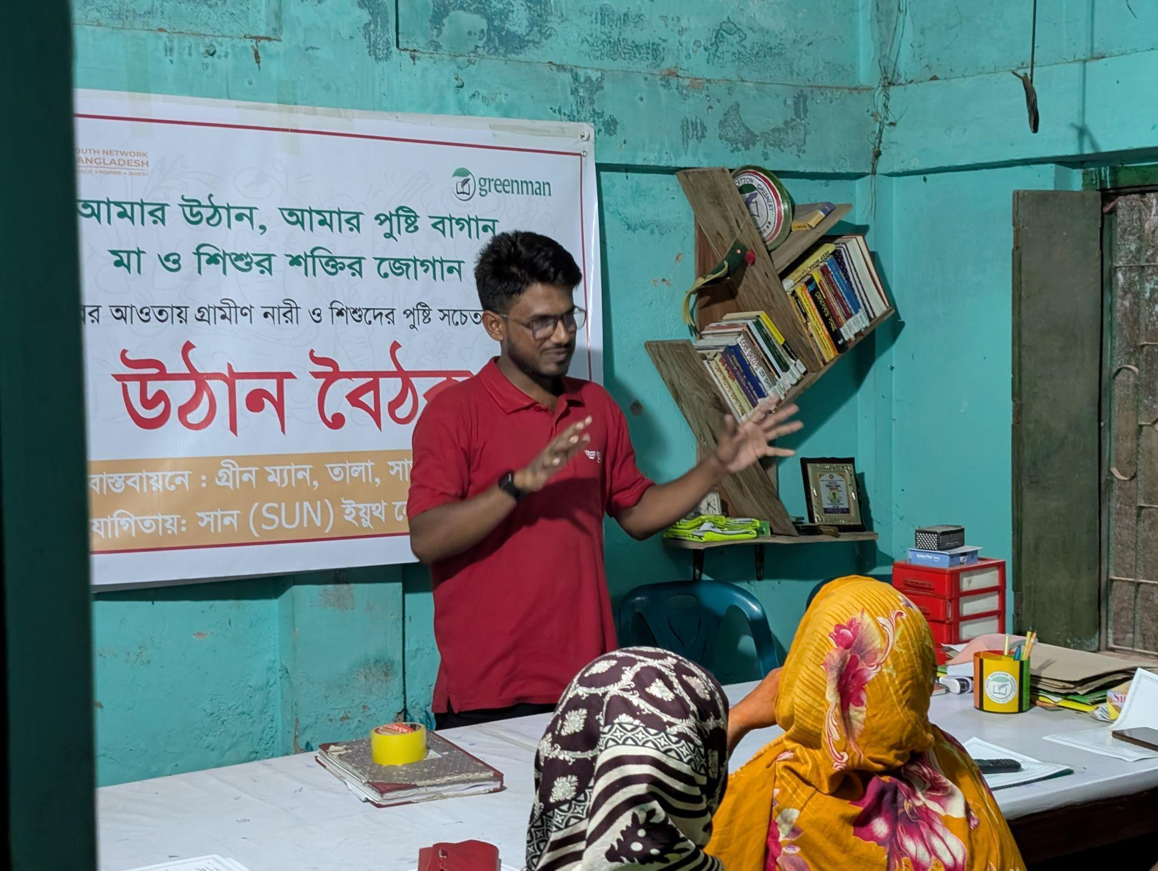
“When I returned home and spoke with mothers more intentionally, the connection between their struggles and what we learned about local food environments became very clear. Their limited access was not only a matter of poverty but also a gap in the local food system that youth could help address,” he explained.

This led to the creation of “Amar Uthan, Amar Pushti Bagan,” meaning “My Courtyard, My Nutrition Garden,” launched with support from SUN Youth Network Bangladesh and Imran’s youth organization, Greenman. The initiative helps families grow nutrient rich vegetables right in their courtyards, reducing dependence on markets and improving access to fresh foods.
One of the participants, Marufa Begum, mother of twin toddlers, shared how the project changed her daily life. “It was nearly impossible to meet our nutritional needs,” she said. “Now, thanks to this project, most of our daily nutrition comes directly from what we grow.”
The initiative began with a courtyard meeting where women discussed maternal and child nutrition, food security and dietary diversity. Participants then visited a model garden, which helped them visualize what was possible in their own homes. Mothers of children under five later formed peer groups and started cultivating their own gardens. To encourage creativity and sustainability, the project will recognize the three most nutrient rich and well maintained gardens.
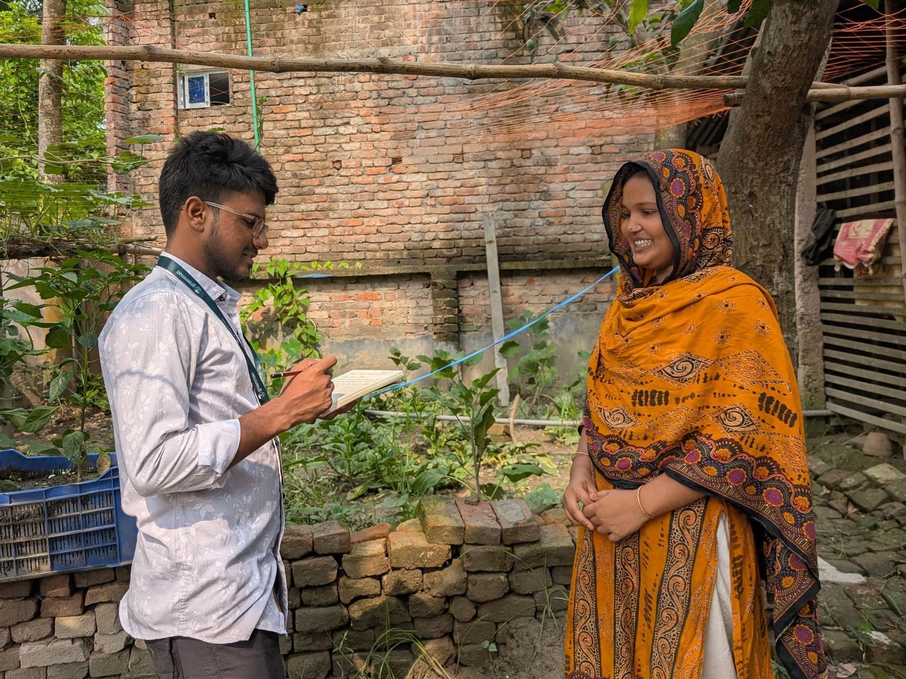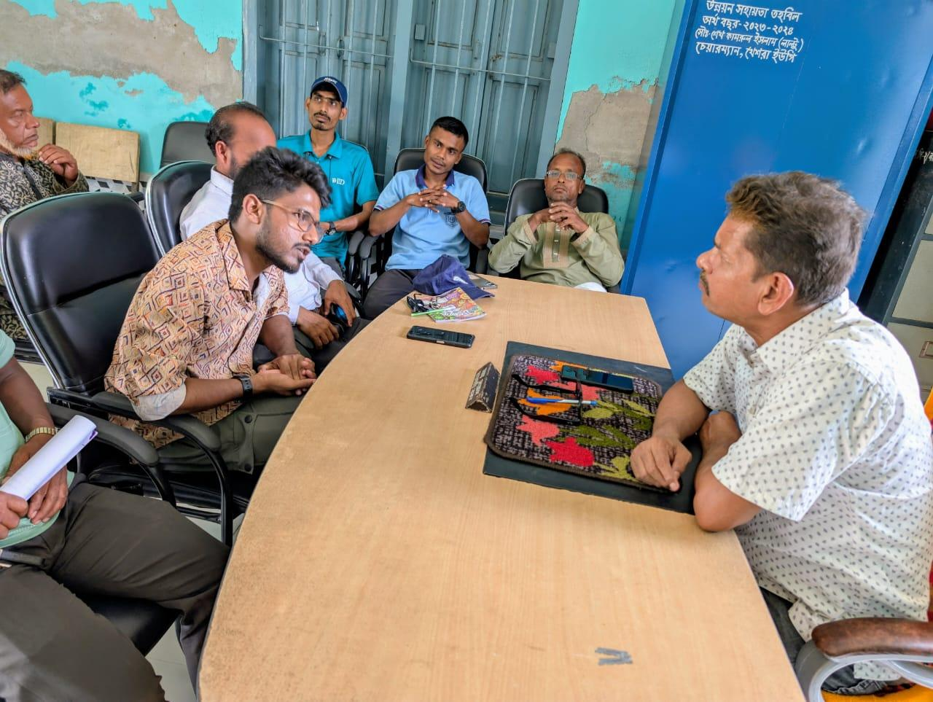

Imran has seen how these small gardens can strengthen families and communities. “Through Amar Uthan, Amar Pushti Bagan, I witnessed how simple, local actions can improve nutrition and support women to take leadership in their households,” he said.
Imran’s work shows how young people can connect national priorities with local realities. By turning knowledge into practical action, he and his peers are helping communities build resilience, improve household nutrition and expand opportunities for women in coastal Satkhira.

